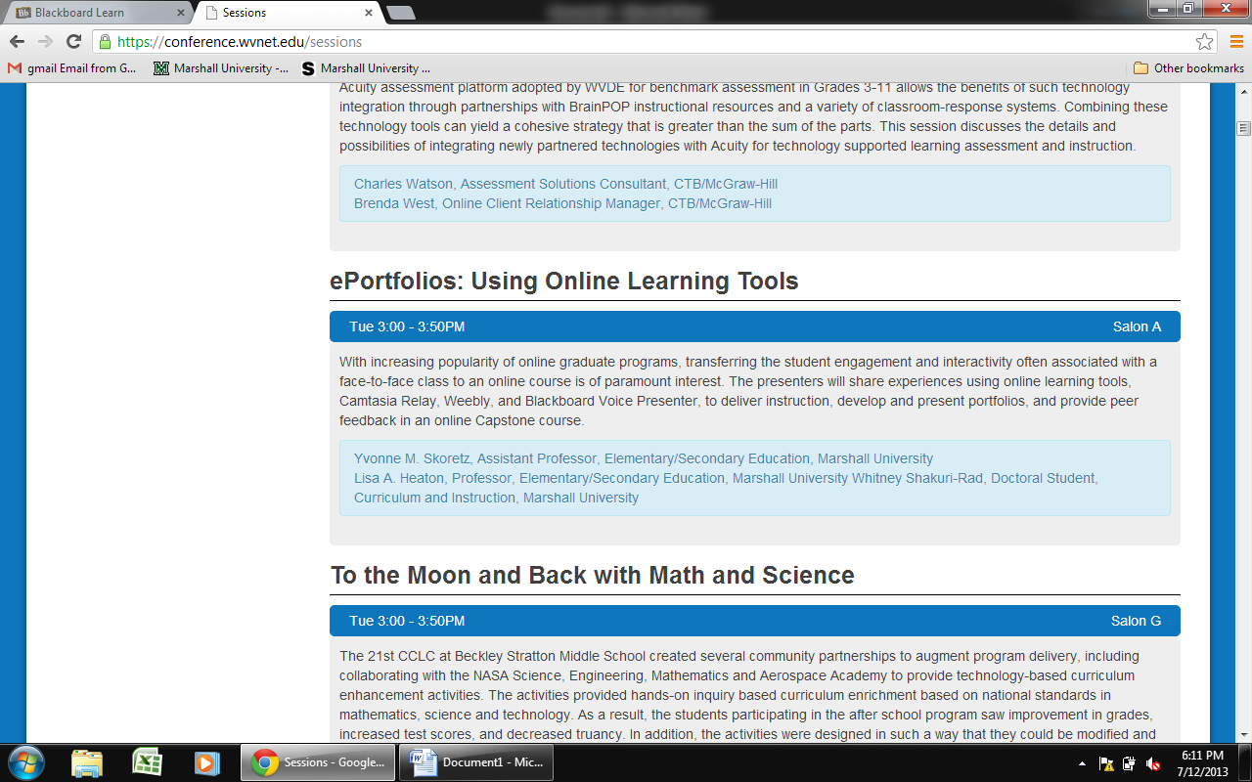
----- Original Message ----
Sent on:Tuesday, July 9, 2013 9:46 AM
Whitney,
That would be great for you to co-present! I had to send a separate message so that I could attach a copy of the conference submission. This is the conference website, and you can click on the sessions to see the schedule: http://conference.wvnet.edu/. We are scheduled for Tuesday at 3:00. I will send the conference organizers a message to add you onto the presentation.

Lisa is drafting an outline of the session and then we can talk about what each would be most comfortable presenting. I am going to start selecting portfolios that I thought would be good examples to share and also comments about the portfolio process from the Goal 6 Reflections and last semester's course evaluation. I think it will be a good session. You will need to register for the conference, even though you will be presenting. I am not sure how that works as a doctoral student, so you may want to find out about that. Is Lisa your chair?
Thanks,
Yvonne

